Bajar zip

<https://github.com/Mirko-veckiardo/EFS_2023/blob/main/Tp%20efs%20temperatura.zip>

En el esquema falta la conexión de gnd de los integrados. 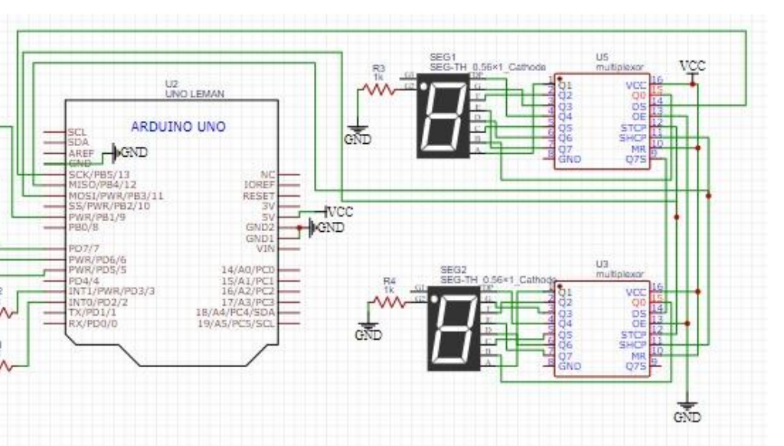

#define latchPin 11 //Salida conectada al pin 12 del 74HC595 (Latch)

#define dataPin 13 //Salida conectada al pin 14 del 74HC595 (Data)

#define clockPin 12 //Salida conectada al pin 11 del 74HC595 (Clock)

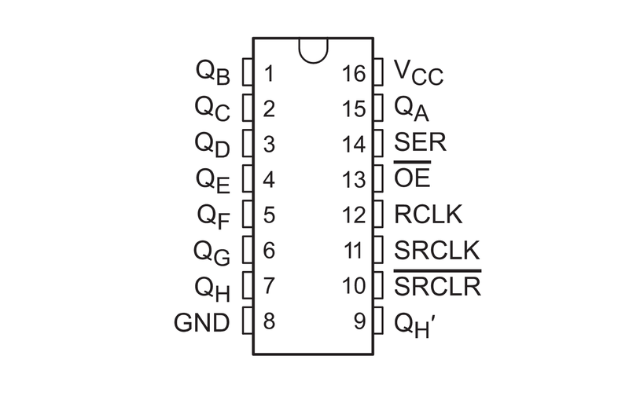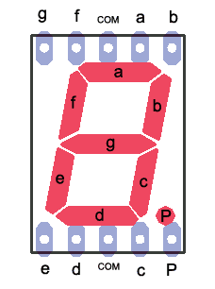

| Arduino | 1 integrando 74hc595 | 1 dig 7seg |  | Arduino | 2 integrando 74hc595 | 2 dig 7seg |
| --- | --- | --- | --- | --- | --- | --- |
|  | 1 | a |  |  | 1 | a |
|  | 2 | f |  |  | 2 | f |
|  | 3 | g |  |  | 3 | g |
|  | 4 | p |  |  | 4 | p |
|  | 5 | c |  |  | 5 | c |
|  | 6 | d |  |  | 6 | d |
|  | 7 | e |  |  | 7 | e |
| gnd | 8 |  |  | gnd | 8 |  |
|  | 9 | 14 del 2 integrado |  | x | 9 | x |
| vcc | 10 |  |  | vcc | 10 |  |
| 12 | 11 |  |  | 12 | 11 |  |
| 11 | 12 |  |  | 11 | 12 |  |
| gnd | 13 |  |  | gnd | 13 |  |
| 13 | 14 |  |  |  | 14 |  |
|  | 15 | b |  |  | 15 | b |
| 5v | 16 |  |  | 5v | 16 |  |

**Dht22**

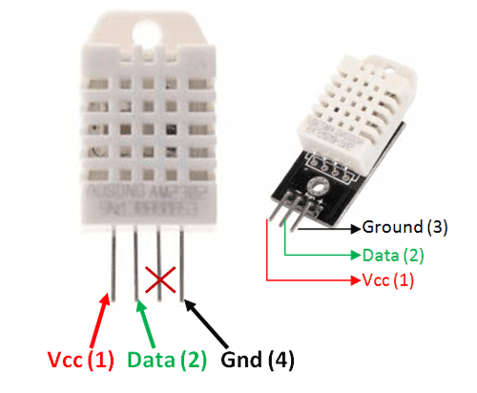

En el código dht22 está conectado al pin 5

**Librerías necesarias**

* adafruit sensor
* DHT-sensor-library
* ShiftRegister74HC595

**Código resumido**

include <ShiftRegister74HC595.h>

#include <Adafruit_Sensor.h>

#include <DHT.h>

#define DHT_PIN 5

#define DHTTYPE DHT22

int temp;

int umbral = 27;

int estadoBoton1;

int estadoBoton2;

#define latchPin 11 //Salida conectada al pin 12 del 74HC595 (Latch)

#define dataPin 13 //Salida conectada al pin 13 del 74HC595 (Data)

#define clockPin 12 //Salida conectada al pin 11 del 74HC595 (Clock)

/*

Los bits 0 son los encendidos (escribí cada posicion en base 1)

--8--

| |

3 7

| |

--2--

| |

4 6

| |

--5-- .1

*/

byte const numbers[10] = {

0b00011000, //0

0b01111011, //1

0b00101100, //2

0b00101001, //3

0b01001011, //4

0b10001001, //5

0b10001000, //6

0b00111011, //7

0b00001000, //8

0b00001011 //9

};

DHT dht(DHT_PIN, DHTTYPE);

void setup() {

pinMode(latchPin, OUTPUT);

pinMode(clockPin, OUTPUT);

pinMode(dataPin, OUTPUT);

Serial.begin(9600);

dht.begin();

}

void loop() {

temp = dht.readTemperature();

Serial.println("Temp: " + String(temp));

pruebaDisplays();

}

///funcion que imprime en los 2 7seg el valor enviado de 2 digitos

void showNumber(byte num) {

//Tomo cada dígito del número que me pasan

byte digit2 = num / 10;

byte digit1 = num - (digit2 * 10);

//Paso bit a bit al multiplexor

digitalWrite(latchPin, LOW);

shiftOut(dataPin, clockPin, MSBFIRST, numbers[digit2]);

shiftOut(dataPin, clockPin, MSBFIRST, numbers[digit1]);

digitalWrite(latchPin, HIGH);

Serial.println("Dígitos: " + String(digit2) + " " + String(digit1));

}

///prueba los 2 7seg con un número

void pruebaDisplays() {

for (int i = 0; i < 10; i++) {

byte digit1 = i;

byte digit2 = i;

digitalWrite(latchPin, LOW);

shiftOut(dataPin, clockPin, MSBFIRST, numbers[digit2]);

shiftOut(dataPin, clockPin, MSBFIRST, numbers[digit1]);

digitalWrite(latchPin, HIGH);

Serial.println(i);

delay(1000);

}

}